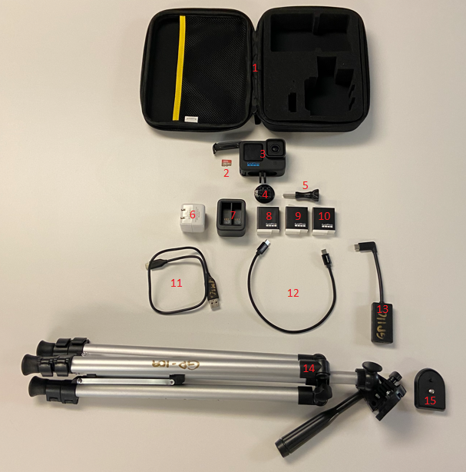
Checklist:
☐ 1) Case
☐ 2) SD Card
☐ 3) GoPro 11
☐ 4) Mounting Buckle
☐ 5) Thumbscrew
☐ 6) Wall Plug
☐ 7) Battery Charger
☐ 8) Battery #1
☐ 9) Battery #2
☐ 10) Battery #3
☐ 11) USB-A to USB-C Cable
☐ 12) USB-C to USB-C Cable
☐ 13) 3.5mm Microphone Adapter
☐ 14) Tripod
☐ 15) Tripod Release Plate

